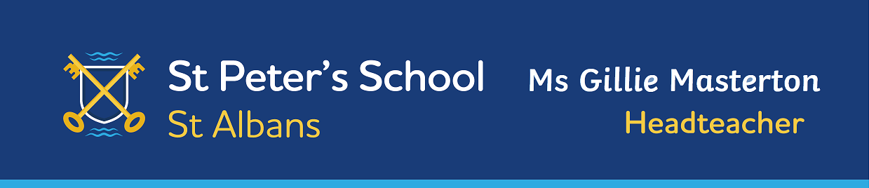

BREAKFAST AND AFTER SCHOOL CLUB
Terms and Conditions
July 2025

 | BREAKFAST CLUB | AFTER SCHOOL CLUB
Times | 7.45-8.50am | 3.15pm -6.00pm Monday-Thursday  3.15pm – 5pm Friday  Session times are;  3.15pm-4.15pm  3.15pm-5pm  3.15pm-6pm
Year groups | Reception – Year 6 | Reception – Year 6
Costs | £9.00 per session  10% discount for second and subsequent sibling/s only, when booking more than one child onto the same session. | 3.15pm-4.15pm - £ 9.00  3.15pm-5.00pm - £13.00  3.15pm-6.00pm - £16.00  10% discount for second and subsequent sibling/s only, when booking more than one child onto the same session.
Bookings | Bookings should be made via the School Gateway. Payment will be required at time of booking. Parents may select the sessions that the children attend and this can be different from week to week.
Activities | A nutritious breakfast is served, comprising of a choice of healthy cereals, toast with a variety of toppings, fruit, fruit juices and milk. Children are not permitted to bring their own food as we have a number of children with food allergies. | Children will have a variety of activities and resources available. They will follow a timetable of carefully planned activities as well as having free time. During the afternoon we will serve a light snack.

BREAKFAST AND AFTER SCHOOL CLUB

- Bookings should be made via the School Gateway where you will be able to book up to a term in advance. Places are limited so please book in good time. If you require any additional sessions at short notice you can check availability and book online up to seven days in advance. Please call the office to inform us if your child is not going to attend for any reason. You may cancel or amend a session online up to 7 days in advance. Cancellations within the seven days (including for reasons of sickness) need to be notified to the school office but cannot be refunded.
- Payment is required upon booking unless you are paying by childcare vouchers. If you are paying by childcare vouchers please ensure that you use your child’s name as a reference for the payment. If you are booking two or more siblings onto the same session please apply the 10% discount to the second and subsequent children only and pay the discounted amount via the School Gateway payments option.
- Late collections outside of the session booked will be subject to a charge of £11.00 per child. Late collections after 6.30pm will incur a charge of £16.00. The late fee will be added to your School Gateway account. Frequent late collections will result in the place being withdrawn. During club hours please call the school number or email mychildtoday@stpeters.herts.sch.uk to inform us of any changes to arrangements.
- Please ensure that your child arrives at Breakfast Club by 8.20am if they require food.
- There is no after school club on the last day of each term when school closes at 1.30pm.
- In the event of bad weather and the school being closed, the breakfast and after school clubs will be cancelled.

Please complete and return this slip to the school office. Thank you.
BREAKFAST AND AFTER SCHOOL CLUB
Childs name: ………………………………………… Date of Birth ………………………..……Class ..………

Any medical Conditions ………………………………………………………………………………………………………………………………

Child’s Food Allergies ………………………………………………………………………………………………………………………………….

Parent Emergency Contact No……………………………………… Alternative Contact No

Email address ……………………………………………………………………………………………………………..…………………

- I give the After School Club staff permission to administer any medication supplied to the school by myself.
- I give permission for my child to watch suitable PG films.
- I agree and accept the above terms and conditions.

Parent Signature………………………………………………… Date ………………………………………

July 2025


