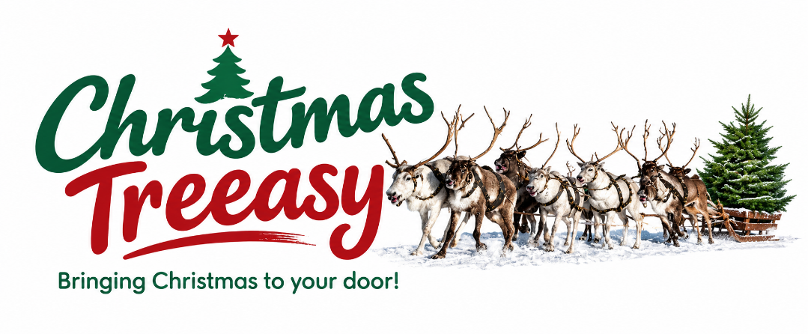

Dear Parents,
🎄 Christmas is just around the corner! 🎄
We’re delighted to remind you about the fantastic Christmas tree delivery and recycling service from Christmas Treeasy, which is available through our school. For every tree purchased through the school by parents, staff, family, friends or colleagues, Christmas Treeasy will donate £3.50–£6.50 per tree to our school/PTA fund, depending on the size of the tree.
🎄 Premium Christmas Trees Delivered to Your Door
Christmas Treeasy specialise in top-grade Nordmann Fir Christmas trees – a popular non-drop variety – and offer free delivery directly to your home.
You can also add:
- ♻️ Christmas tree recycling – your tree will be collected and recycled in the New Year
- 🌲 Tree stands
- 🪵 Bags of logs
🌟 Going Big This Christmas?
Their 9ft and 10ft Nordmann Fir trees are available by special pre-order, along with Extra Large Cinco stands.
If you’re thinking big this Christmas, please place your order by 20th November.
There are 16 delivery dates available this year, but weekend slots are filling up quickly, so we recommend ordering early to avoid disappointment.
🎁 How to Order
- Visit www.christmastreeasy.co.uk
- Choose your preferred tree size
- Add recycling, a stand or logs if required
- Select our school when placing your order
- Choose your preferred delivery date
Please make sure you select our school when ordering, as this is how Christmas Treeasy will allocate the donation to our school/PTA.
For more information, contact Christmas Treeasy on 07710 407149 or enquiries@christmastreeasy.co.uk.
Thank you for supporting our school while getting your perfect Christmas tree delivered straight to your door!
Wishing you all a wonderful Christmas.
Kind regards,
Dean Turner
Christmas Treeasy Ltd.

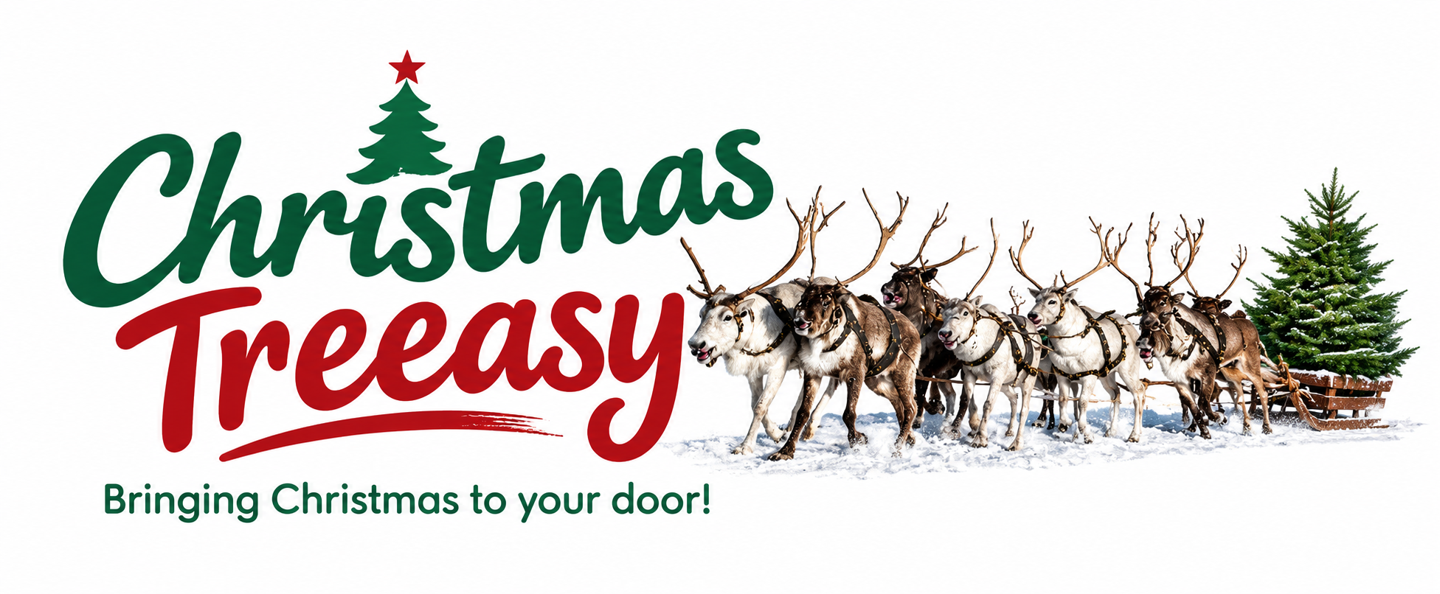

PREMIUM CHRISTMAS TREES 2026
Luxury Nordmann Firs • Beautifully Fresh • Delivered to Your Door
❦ PREMIUM DELUXE NON-DROP NORDMANN FIR ❦
SIZE OF TREE | PRICE PER TREE | QTY ORDERED
4ft to 4'8" | £44.00
4'8" to 5'6" | £52.00
5'6" to 6'4" | £59.00
6'4" to 7'2" | £69.00
7'2" to 8ft | £76.00
8ft to 9ft | £92.50 | PRE-ORDER BY 20th NOV
9ft to 10ft | £112.50 | PRE-ORDER BY 20th NOV
❦ CINCO TREE STANDS ❦
SIZE OF STAND | PRICE PER STAND | QTY ORDERED
SMALL | £19.50
MEDIUM | £22.50
LARGE | £30.00
EXTRA LARGE | £40.00
❦ CHRISTMAS EXTRAS ❦
ITEM | PRICE | QTY ORDERED
5KG BAG OF XMAS LOGS | £5.00
10KG BAG OF XMAS LOGS | £9.00
RECYCLING OF XMAS TREE | £7.50

TREE RECYCLING
Recycling of Christmas trees will take place between 7th & 10th January. Please leave your tree outside your door ready for collection.
❦ CHRISTMAS TREE DELIVERY DATES ❦
27th Nov | 28th Nov | 29th Nov | 30th Nov
1st Dec | 3rd Dec | 4th Dec | 5th Dec
6th Dec | 8th Dec | 10th Dec | 11th Dec
12th Dec | 13th Dec | 15th Dec | 17th Dec
PLEASE NOTE Deliveries can start very early. Please specify a safe place to leave your tree if you are out. We will give you an ETA a few days before.
❦ HOW TO PLACE AN ORDER ❦
1. Go to the shop page online at: www.christmastreeasy.co.uk
2. Choose your size of tree.
3. Add recycling, a stand or Christmas logs to your order if you wish.
4. Add your school from the drop-down box.
5. Choose your preferred delivery date from the available options.
✦ CONTACT CHRISTMAS TREEASY ✦
enquiries@christmastreeasy.co.uk • 07710 407149
www.christmastreeasy.co.uk • Facebook: www.facebook.com/christmastreeasy
Credit card payments can be made online only.

