**Comprehension activities**

Story time:

* Read daily with your child and talk about the pictures

-What is happening?

-How are the characters feeling?

-Can they predict what might happen next?

-Can they suggest an alternative ending?

-Can they talk about the structure of the story and recall information? What happens at the beginning/middle/end?

-Have you read a story like this before? Can you make comparisons and relate it to your own experiences?

* Have fun making up your own stories!

Think about the following:

WHERE- What is the setting for your story?

WHO- Who are the main characters? Is there a good/bad character?

WHAT? What is going to happen? What is the problem? E.g. someone gets lost/comes across an evil character/finds treasure

END- How will your story end/be resolved?

*Vocabulary

-What does this word mean? Can you use it in a sentence?

- Can you make an action to show what it means?

Visit your local library to enjoy reading together!

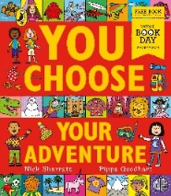

Try out some story telling books to help you. make up your own stories!

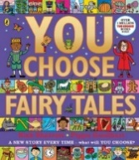

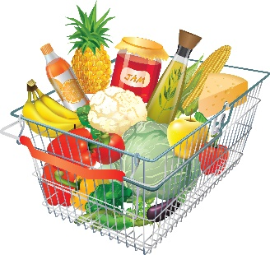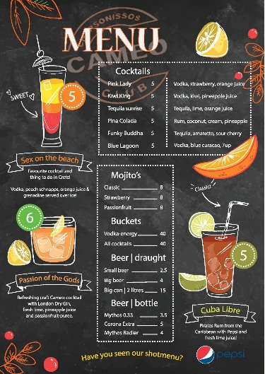

**Role play**

There are lots of fun ways to encourage your child to communicate and play is the best one! Consider their interests and come up with a simple role play scenario to encourage them to engage in dialogue and conversation with you.

When role playing consider:

* Props- what can you use to make it more realistic (a lot of the time this means stuff around the home rather than items bought from a shop)
* Modelling

- what are the different roles that can be played?

-model each role and use **key vocabulary** which they can use in their play e.g “Hello how can I help you?” “That will be £3 please”. Children will quickly pick this up and be keen to repeat this language.

* Opportunities for more learning:

-Is there a purposeful way to bring mark making, counting or phonics in to this? E.g. counting how much something costs in the shop or writing a shopping list. **\* keep it fun and low pressure depending on their interest even if this means them mark making’ scribbles’ or ‘lines’ rather than wanting to try and write words- this will still help their fine motor development\***