Skill: To give meaning to marks/to use letters to communicate meaning.
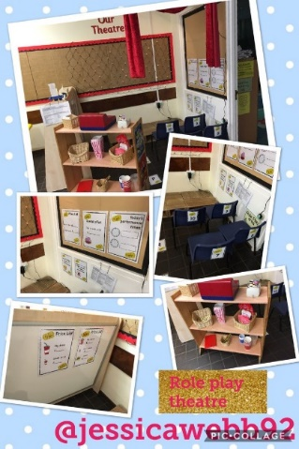
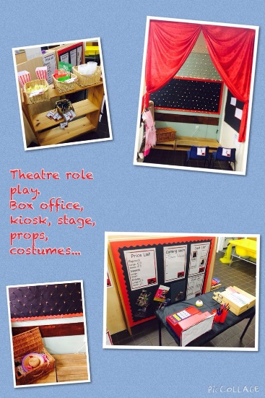
Activity ideas: To make a ticket/poster for a theatre show with pictures/letters
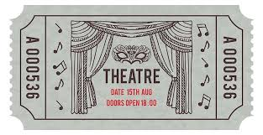
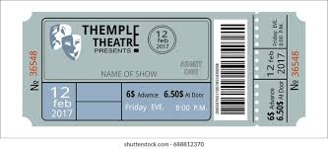
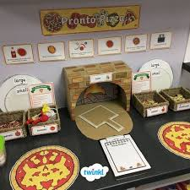
Skill: 1. To write the initial sound in a word OR
2. To segment the beginning, middle and end sound in a word.

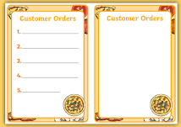
Activity ideas: To write down someone’s order or to make a menu.
Skill: 1. To record results on a table using symbols or words.
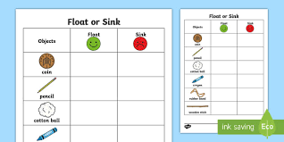
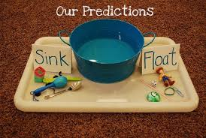
Activity ideas: Does it float or does it sink? How can you record your results?
Skill: 1. To give meaning to marks.
2. To segment the sounds in words to write a label.
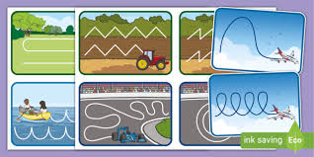
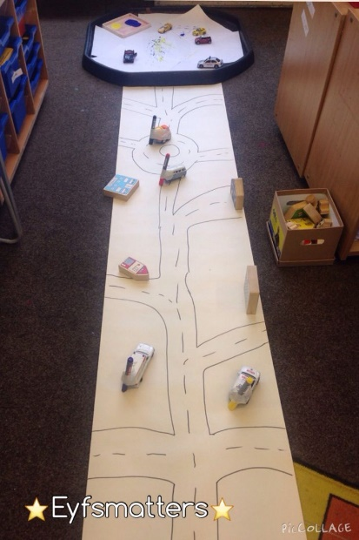
Activity ideas: To draw a map of a town/land for the vehicles to travel across. You could try labelling what you have drawn.
Activity ideas: To make cupcakes using playdough and make labels to create a shop.
Skill:
1. To use pinching, rolling, pushing and pulling to manipulate the playdough into desired shape.
2. To write the initial sound in a word or segment the beginning, middle and end sound in a word to create shop labels.
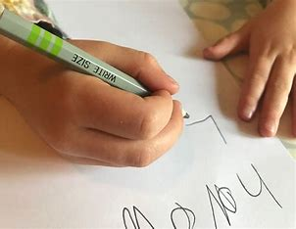
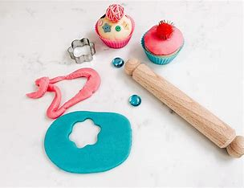
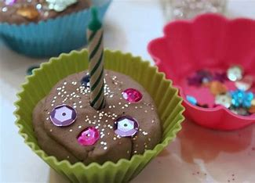
Activity ideas: Can you use the hamma beads to make a pattern using Diwali patterns as inspiration?
Skill: To use their pincer grip to place the beads onto the boards.
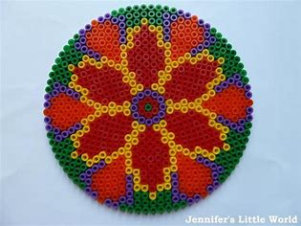
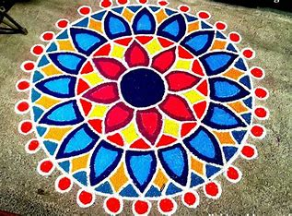
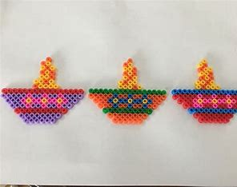
Activity ideas: Can you role play being a class teacher?
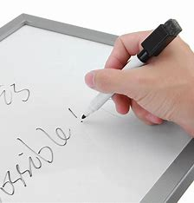
Skill:
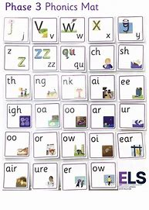
- To use imaginative play skills to role play being a teacher.
- To use mark making and language skills.
Activity ideas: Question: “What is your favourite….?” Create a tally chart recording people’s answers.
Skill: Use marks, symbols or pictures to record your results.
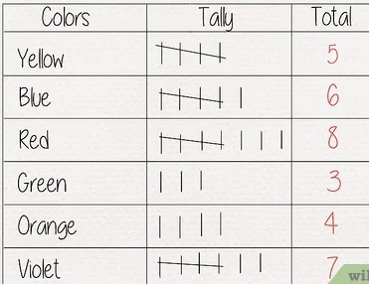
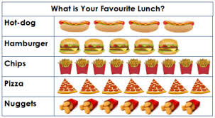
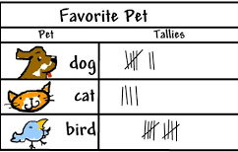
Activity ideas: To use the paint to create a picture. You can use the images to help you or think of your own idea.
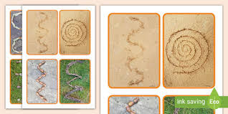
Skill:
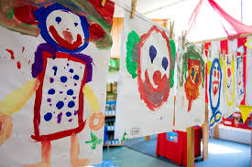
- To hold the paintbrush using a pincer grip and experiment with making different marks.
- To create simple representations using shapes and marks.

