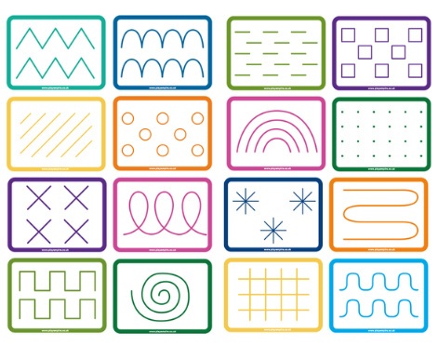
Skills:
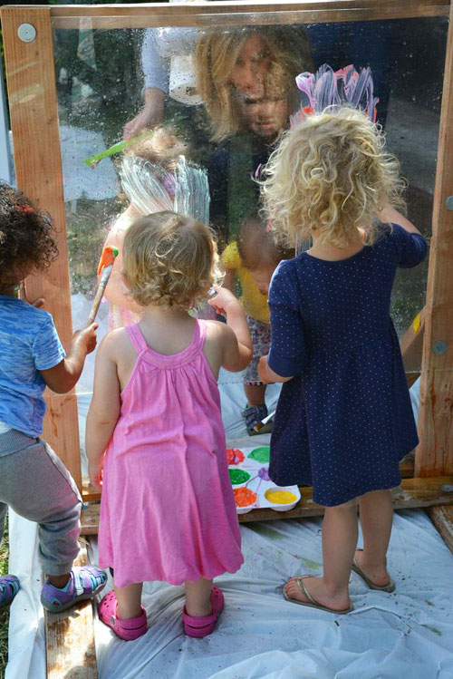
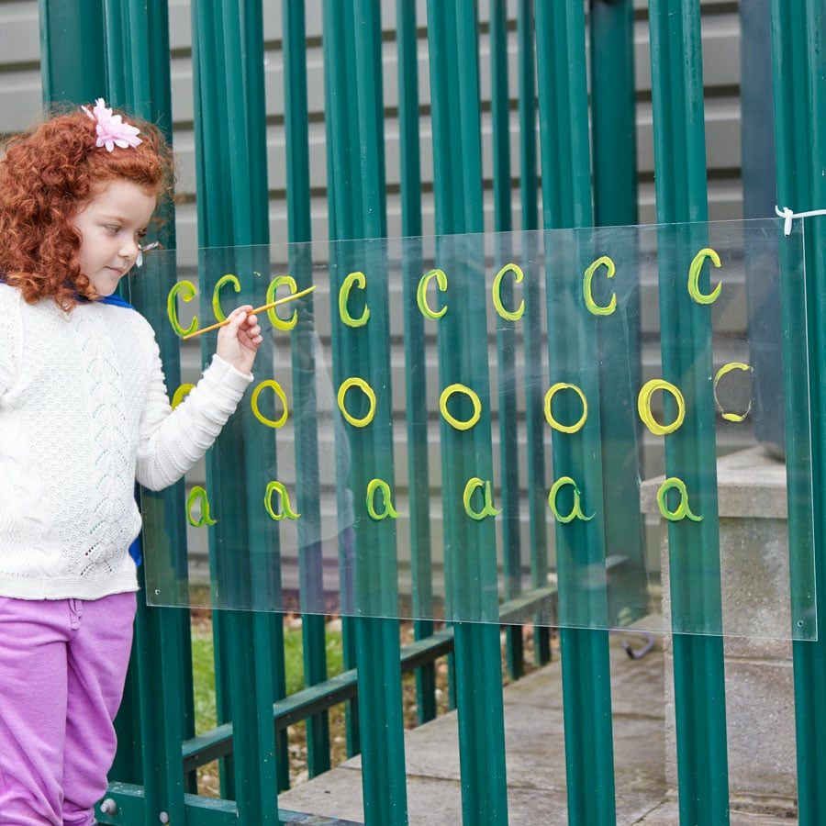
To use large-muscle movements to paint and make marks. To show a preference for a dominant hand. To write some letters accurately. To develop their small motor skills so that they can use a range of tools competently, safely and confidently.

Activity ideas:
To make marks and form letters on the perspex sheet.
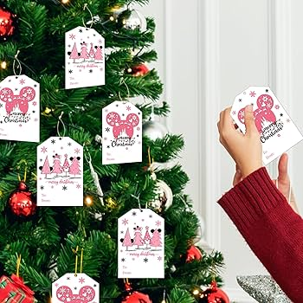
Skills:
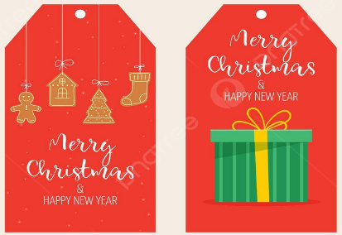
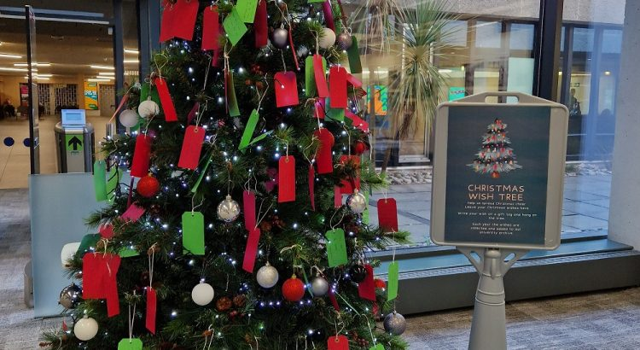
To show a preference for a dominant hand. To use a comfortable grip with good control when holding a writing implement. To write some letters accurately. To write short sentences with words with known sound-letter correspondences using a capital letter and full stop.

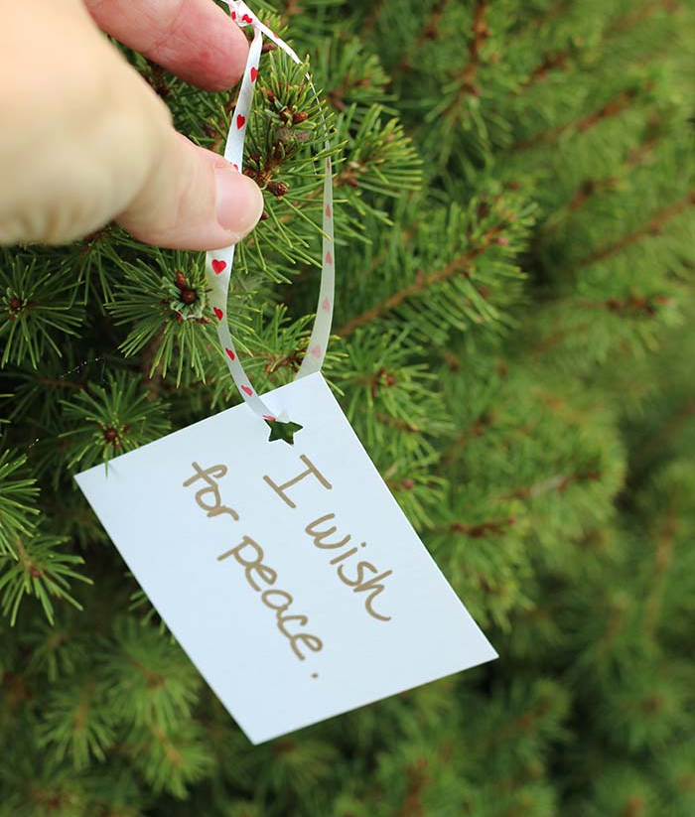
Activity ideas:
To write a celebratory message or Christmas wish to hang on the Christmas tree.
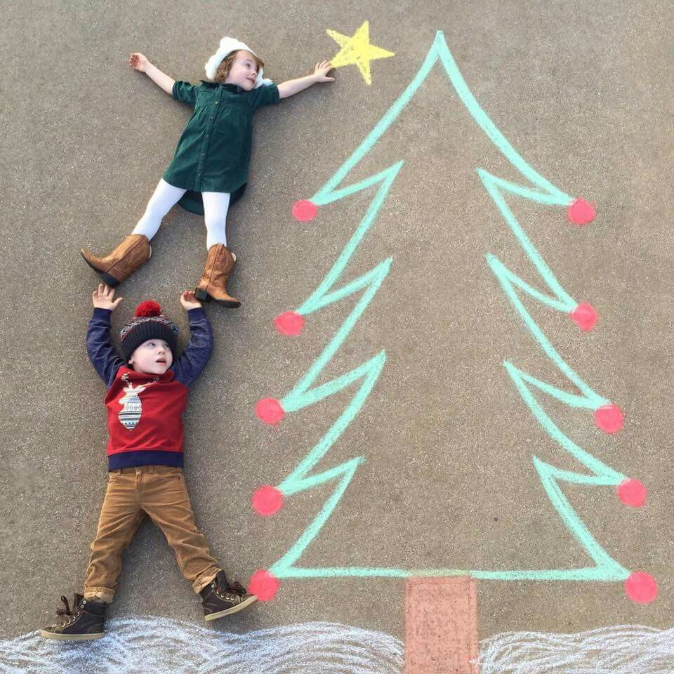
Skills:
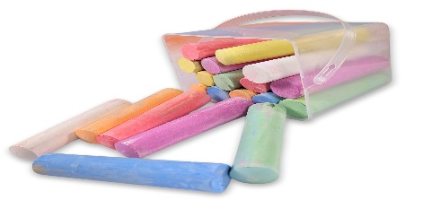
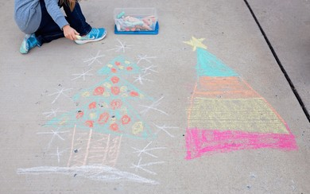
To use large-muscle movements to make marks. To show a preference for a dominant hand. To use a comfortable grip with good control when holding a writing implement. To develop their small motor skills so that they can use a range of tools competently, safely and confidently.
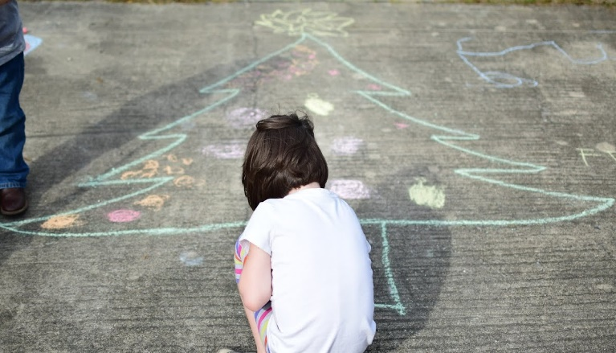
Activity ideas:
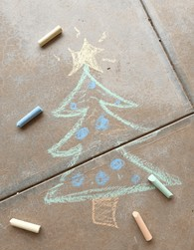
To add Christmas decorations to the Christmas trees drawn on the floor using chalks.
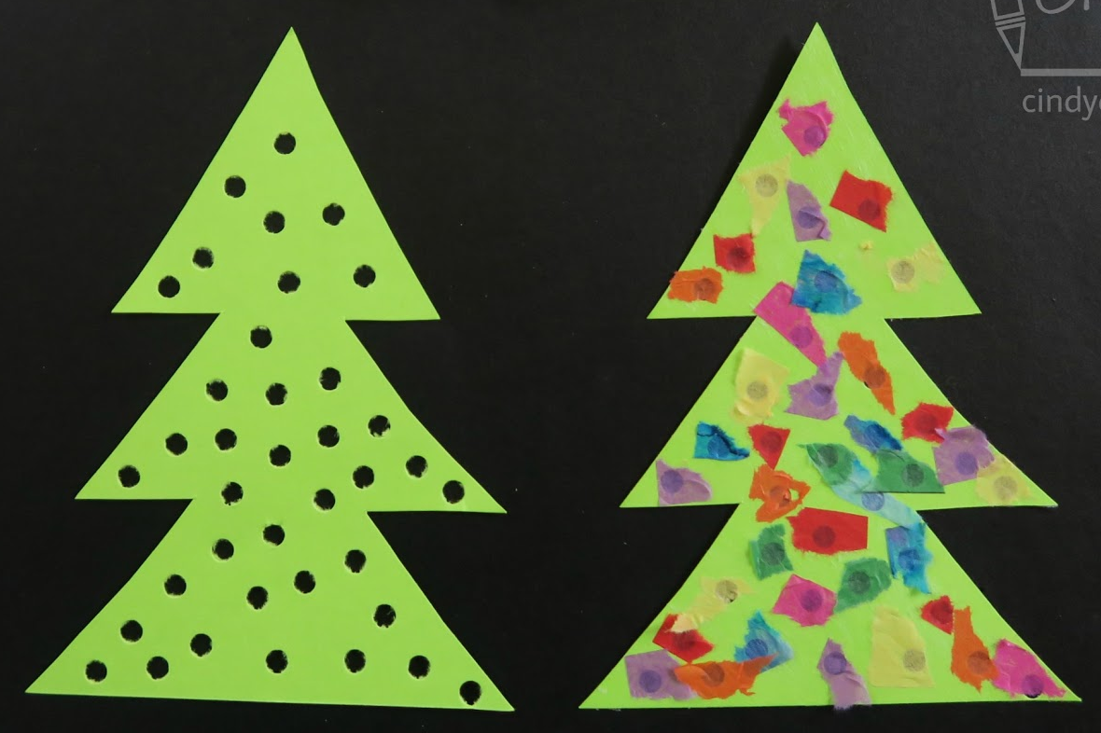
Skills:
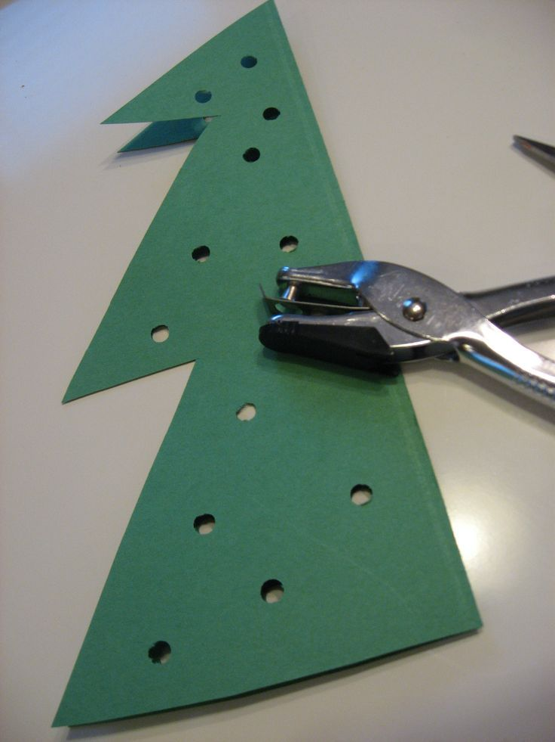
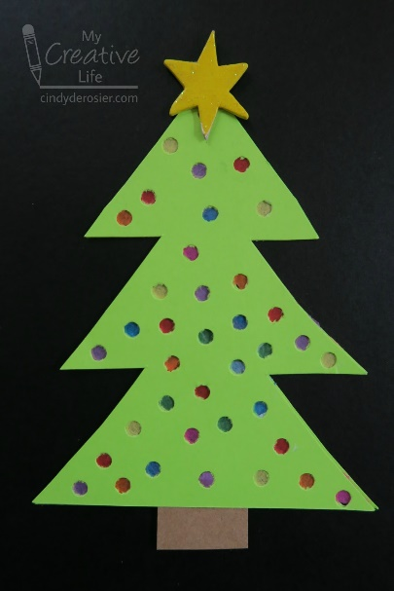
To use one-handed tools and equipment, for example, making snips in paper with scissors. To develop their small motor skills so that they can use a range of tools competently, safely and confidently.

Activity ideas:
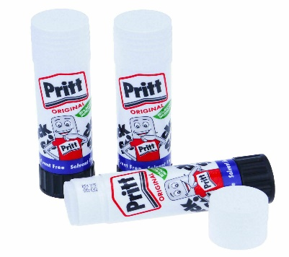
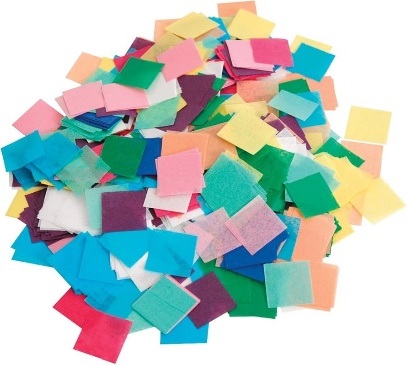
To create Christmas tree decorations using a range of materials and techniques.

Skills:
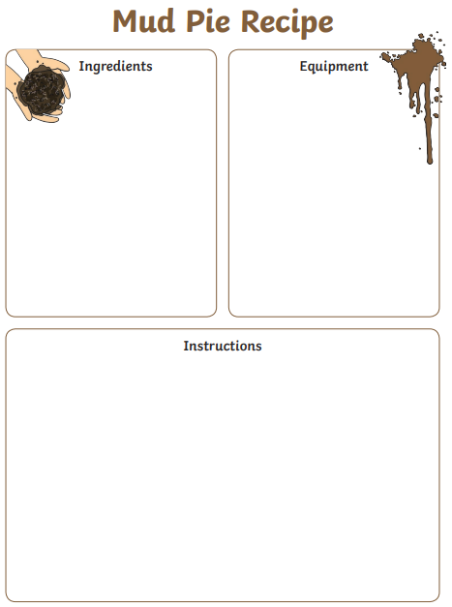
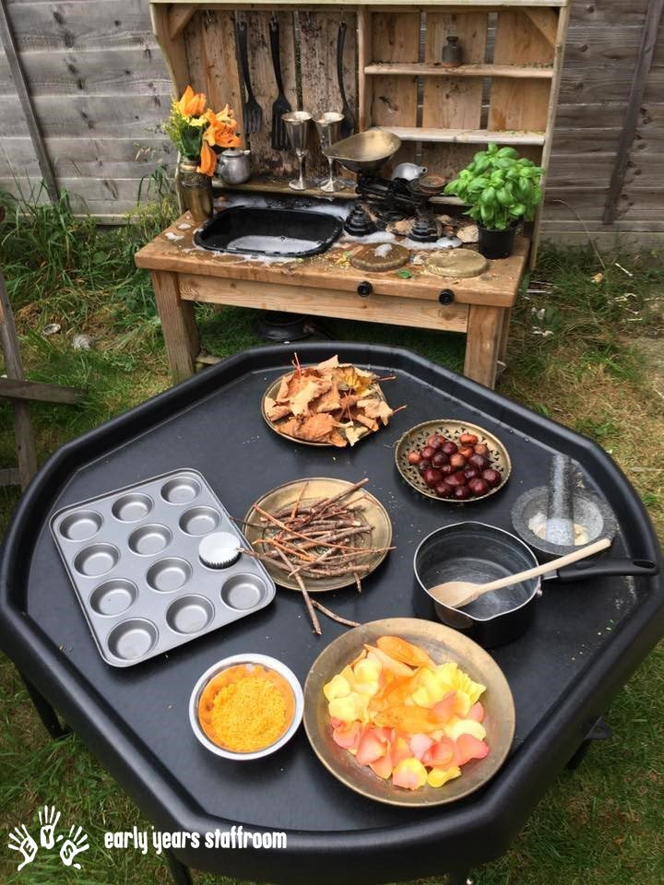
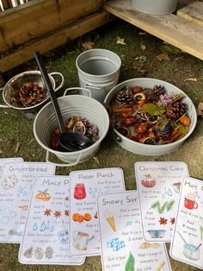
To show a preference for a dominant hand. To use a comfortable grip with good control. To write some letters accurately. To add some marks to their drawings, which they give meaning to. To write short sentences with words with known sound-letter correspondences using a capital letter and full stop.
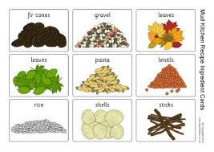
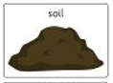
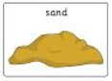
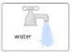
Activity ideas:
To write a mud kitchen recipe.
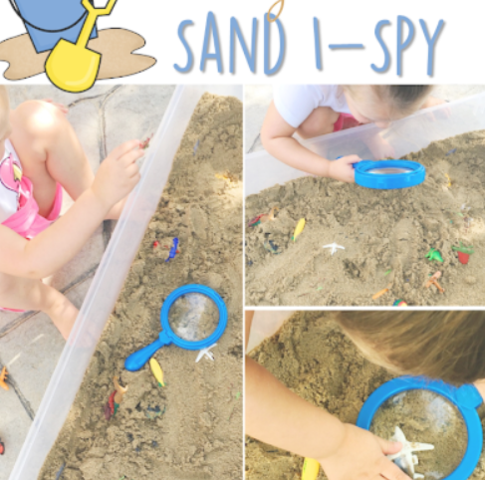
Skills:
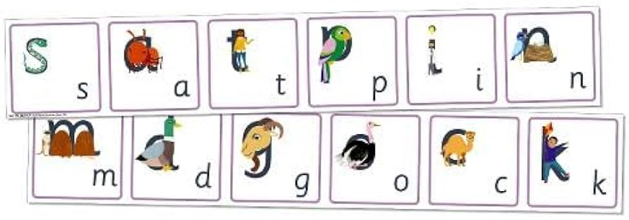
To show a preference for a dominant hand. To use a comfortable grip with good control when holding a writing implement. To write some letters accurately. To add some marks to their drawings, which they give meaning to. To spell words by identifying the sounds and then writing the sound with letter/s.

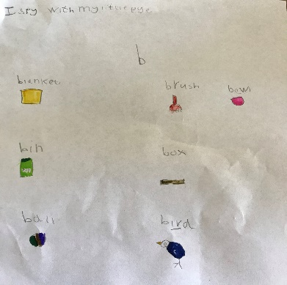
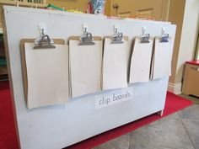
Activity ideas:
To write the sounds or draw an object to represent the objects found hidden in the sand.

